Big Data Analytics Final Project report
Microsoft Malware Prediction
Submitted By:
Shubhangi Srivastava (UIN: 664059843)
Pawanjeet Kaur (UIN: 665083019)

Introduction
Malware industry has always been a crucial part of the digital market as it has the potential to invade a traditional secure system. Once a system has been infected with malware, the criminals can use that to their benefits in numerous ways. Malware detection is crucial because it gets more complicated by the introduction of new machines in the environment, machines that come online and offline, machines that receive patches or the ones that receive new operating systems, etc. As Microsoft is having more than one billion enterprise and consumer customers, Microsoft takes this problem very seriously and has always been deeply invested in improving security of their machines. As part of it, one of the initiative to find the best solution to this problem, Microsoft challenged the world wide data science community to develop techniques, based on various features of the machine, that can identify and predict if a machine is soon to be hit by the malware accurately.

Goal
The goal of this project is to predict a Windows machine’s probability of getting infected by various families of malware, based on different properties of that machine. We will train various Machine Learning models using PySpark’s MLIB and predict the best outcome on our test dataset.

About the dataset
Our dataset was fetched from Kaggle(Microsoft malware prediction challenge). The original dataset had 8,921,483 rows and 82 columns. Each row in this dataset corresponds to a machine, uniquely identified by a ‘MachineIdentifier’. The dependent variables ‘HasDetections’ and it indicates if Malware was detected on the machine or not.

Some of the features of the dataset are described below:

Column | Description
MachineIdentifier | Individual machine ID
ProductName | Defender state information e.g. win8defender
EngineVersion | Defender state information
IsBeta | Defender state information (True/False)
DefaultBrowsersIdentifier | ID for the machine's default browser
AVProductStatesIdentifier | ID for the specific configuration of a user's antivirus software
HasTpm | True if machine has tpm
CountryIdentifier | ID for the country the machine is located in
Platform | Calculates platform name
Processor | This is the process architecture of the installed operating system
OsVer | Version of the current operating system
IsProtected | True if there is at least one active and up-to-date antivirus product running on this machine else False
PuaMode | Pua Enabled mode from the service
SmartScreen | SmartScreen enabled string value from registry.
Census_OSEdition | Edition of the current OS.

Challenges:
We have decided to work on this particular data because the dataset was huge and fits perfectly for big data requirements. Also, handling such big dataset on machine with less power was a challenging problem. As it is the real time data collected by Microsoft it consists huge amount of missing values which makes it challenging to explore and find impact of these variables on target variable. The dataset consists of mixed type variables due to which categorical feature encoding was performed. Then to build a draft ML model for this dataset was challenging yet exciting.

Data Exploration and Pre-Processing
As our dataset consists of large number of windows machine’s data from all over the world. We did some exploratory data analysis and understood the different relationship among 82 columns. Every column in dataset provides us with some information of the machine for instance, the ‘OSVer’ provides us the information about operating system the machine is running. To find out if any specific type of OS is getting effected by malware this is very important field. For our work, we first analysed some of the columns using Tableau.

First, we plotted the distribution of ‘HasDetections’
across dataset. Target variables take two different
values ‘0’ i.e. machine is not effected by Malware
and ‘1’ i.e. machine is effected by Malware. We can
see from the plots that the data is equally divided
among two classes in ‘HasDetections’.

Figure(1) On the right depicts the relation in histogram:

As next step, we calculated the NA i.e. missing values in the dataset. We had couple of ways to handle NA’s:
- Drop Missing Values – Depending upon the percentage of missing values we dropped entire column with high percentage of NA’s
- Imputing Missing Values- We used imputation for rest of the columns. We imputed Na values with Mean or Mode.
Figure(2) shows code to calculate NA values in dataset, sorted based on the percentage value.

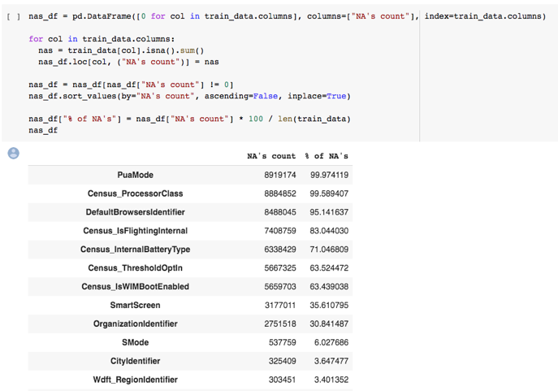
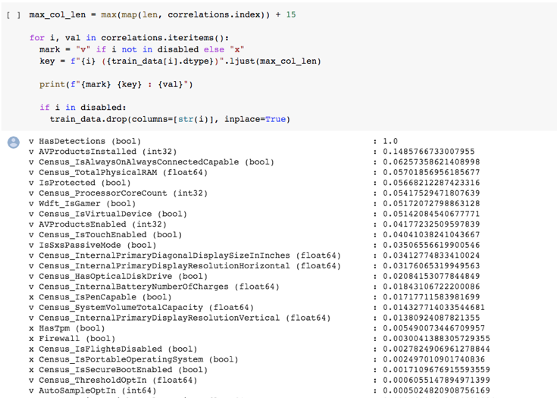
We removed ‘MachineIdentifer’ from our
analysis of correlation as it is unique for
every machine and does not provide any
correlation with the dependent variable.

Further, to analyse the dataset, we did
calculate the correlation of different
columns with target variable.

Figure(3) on right shows the code to find
the correlation and output corresponding
to that:

After the initial cleaning we converted our cleaned data into PySpark’s DataFrame to make it suitable for machine learning algorithms.

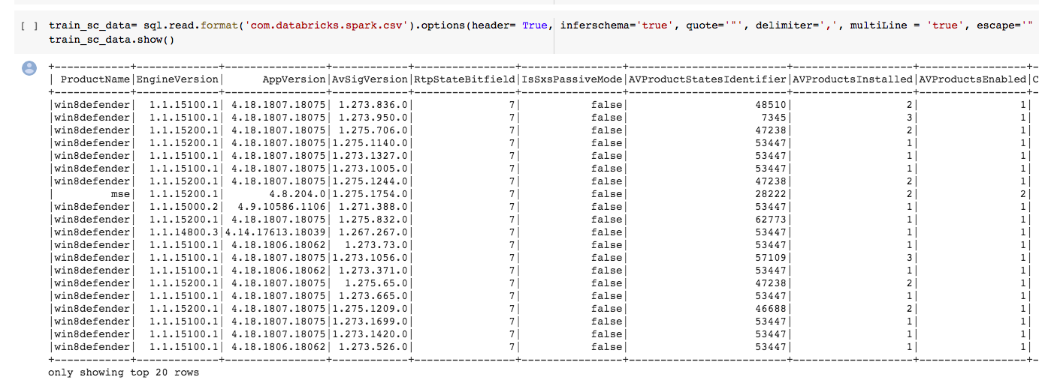

Finally, we performed Feature Encoding .The different data types of the features were handled using ‘StringIndexer’ for string type , ‘OneHotEncoderEstimator’ for categorical and ‘VectorAssembler’ to create assembler for creating a single factor which shows all the variables we want to use in our model.

As the dataset for this project was huge and it became difficult for Colab Pro to handle we reduced our dataset to 40K rows and further divided into test and train with 70-30 ratio.

Data Modelling Techniques
Further we developed different machine learning techniques on our dataset. As this is a classification problem we went ahead with three following models:

- Logistic Regression: Logistic regression is a supervised classification algorithm. In a classification problem, the target variable(or output), y, can take only discrete values for given set of features(or inputs), X.

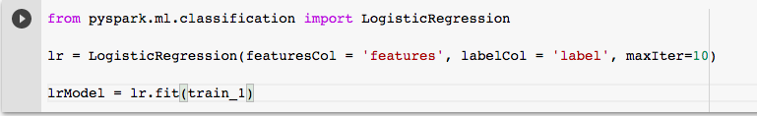
- Decision Tree: A Decision Tree is a simple representation for classifying examples. It is a Supervised Machine Learning where the data is continuously split according to a certain parameter. It consists of the following:
  - Nodes : Test for the value of a certain attribute.
  - Edges/ Branch : Correspond to the outcome of a test and connect to the next node or leaf.
  - Leaf nodes : Terminal nodes that predict the outcome (represent class labels or class distribution).
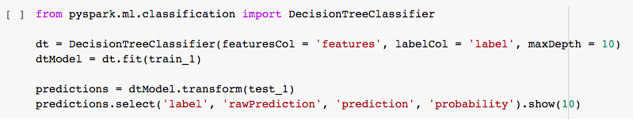

- Random Forest: It is an ensemble tree-based learning algorithm. The Random Forest Classifier is a set of decision trees from randomly selected subset of training set. It aggregates the votes from different decision trees to decide the final class of the test object.

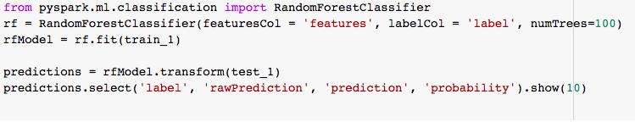

Results
Models | Accuracy
Bench Accuracy | 70%
Logistic Regression | 66.7%
Decision Tree | 51.8%
Random Forest | 65.8%

We got best results for given dataset for Logistic Regression with 66.7%. Below are ROC and Recall-Precision plots for Logistics regression:
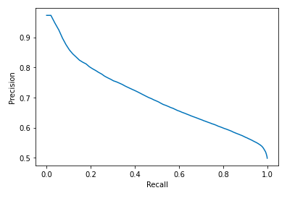
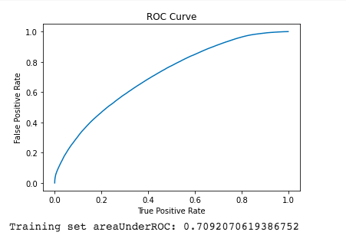

Team Member Role:

Shubhangi Srivastava cleaned the dataset and performed exploratory data analysis along with visualization plots. Model building, hyperparameter tuning was done by Pawanjeet Kaur.

